
SRM Institute of Science and Technology
Mode of Exam
OFFLINE – SET D

College of Engineering and Technology
School of Computing
DEPARTMENT OF COMPUTING TECHNOLOGIES
SRM Nagar, Kattankulathur – 603203, Chengalpattu District, Tamilnadu
Academic Year: 2022-2023 (ODD/EVEN): ODD
Test: CLAT-1 Date: 08-09-2022
Course Code & Title: 18CSE356T - DOS Duration: 1 Hour
Year & Sem: III & V Max. Marks: 25

Course Articulation Matrix: (to be placed)
S.No. | Course Outcome | PO1 | PO2 | PO3 | PO4 | PO5 | PO6 | PO7 | PO8 | PO9 | PO10 | PO11 | PO12
1 | CO1 | 3 | 2 | 2 | 3 | 3 | 2 | - | - | 3 | 2 | - | 3

Part - A
( 15 x 1 = 15 Marks)
Instructions: Answer all
Q. No | Question | Marks | BL | CO | PO | PI Code
1 | In distributed system, each processor has its own ___________  a. Local memory  b. Clock  c. Both local memory and clock  d. storage | 1 | 1 | 1 | 1 | 1.6.1*
2 | Distributed Operating System works on the _____ principle  a. File foundation  b. Single system image  c. Multi system image  d. Networking image | 1 | 1 | 1 | 1 | 1.6.1*
3 | in distributed systems, link and site failure is detected by ___________  a. handshaking  b. polling  c. token passing  d. sampling | 1 | 2 | 1 | 1 | 1.6.1*
4. | ______ of the distributed file system are dispersed among various machines of distributed system.  a. clients  b. servers  c. storage devices  d. both client and server, storage devices | 1 | 2 | 1 | 1 | 1.6.1*
5. | ____ is software architecture used to build a distributed system from a network connected by high speed network.  a. DOS  b. NOS  c. Middleware  d. Operating system | 1 | 2 | 1 | 1 | 1.6.1*
6. | If one site fails in distributed system  a. the remaining sites can continue operating  b. all the sites will stop working  c. directly connected sites will stop working  d. not affected any of the sites | 1 | 3 | 1 | 1 | 1.6.1*
7. | Transparency that enables multiple instances of resources to be used, is called  a. Scaling transparency  b. Concurrency transparency  c. Replication transparency  d. Performance transparency | 1 | 3 | 1 | 1 | 1.6.1*
8. | The capability of a system to adapt the increased service load is called  a) scalability  b) tolerance  c) capacity  d) performance | 1 | 3 | 1 | 1 | 1.6.1*
9. | Which of the following term is best defined by the statement “In a distributed system, several processes may operate at the same time on separate computers on the network.”?  a. Concurrency  b. Openness  c. Resource sharing  d. Fault tolerance | 1 | 3 | 1 | 1 | 1.6.1*
10. | In a bus-based multiprocessor, whenever a word is written to the cache, it is written to memory as well. This policy is known as ____________  a. Write back  b. Write around  c. Write through  d. Write immediate | 1 | 2 | 1 | 1 | 1.6.1*
11. | A multiprocessor operating system must take care of  a. authorized data access and data protection  b. unauthorized data access and data protection  c. authorized data access  d. data protection | 1 | 1 | 1 | 1 | 1.6.1*
12. | All the nodes in distributed system communicate with each other and handle processes in tandem.  a. true  b. false  c. can be true or false  d. cannot say | 1 | 1 | 1 | 1 | 1.6.1*
13. | Scaling transparency hides  a. system expansion  b. system collaboration  c. system failure  d. system security | 1 | 2 | 1 | 1 | 1.6.1*
14. | What is not a major reason for building distributed systems?  a. Resource sharing  b. Computation speedup  c. Reliability  d. Simplicity | 1 | 2 | 1 | 4 | 1.6.1*
15. | Migration in a distributed system provides transparency in the concept of, hide that  a. Resources may be concurrently available  b. May be moved to another location  c. May be moved to another location while in use  d. May be relocated to another location. | 1 | 2 | 1 | 1 | 1.6.1*

Part – B
( 2 x 5 = 10 Marks)
Instructions: Answer all
1 | Explain various design issues to be considered while designing a distributed system.  The key design issues that people contemplating building a distributed operating system must deal with.  Transparency  Should be perceived as the single entity by the users.  User should be unaware of where the services are located and the transferring from a local machine to a remote one should be transparent.  Flexibility  Microkernel - user services and kernel, services are kept in separate address space.  Monolithic kernel,- both user services and kernel services are kept in the same address space.  Reliability  Goals of building distributed systems - To make them more reliable than single-processor systems.  The idea is that if a machine goes down, some other machine takes over the job.  Three important aspects : 1) Availability 2) Security 3) Fault Tolerance  Performance  Always the hidden data in the background is the issue of performance.  Building a transparent, flexible, reliable distributed system, more important lies in its performance.  In particular, when running a particular application on a distributed system, it should not be appreciably worse than running the same application on a single processor.  Scalability  Many services are centralized in the sense that they are implemented by means of only a single server running on a specific machine in the distributed system.  Problem with this scheme is obvious: the server can become a bottleneck as the number of users and applications grows. | 5 | 3 | 1 | 1 | 1.6.1*
2 | Describe the hardware components and types of multicomputer and Multiprocessor in Distributed systems.  In some systems the machines are tightly coupled and in others they are loosely coupled. In a tightly-coupled system, the delay experienced when a message is sent from one computer to another is short, and the data rate is high; that is, the number of bits per second that can be transferred is large. In a loosely-coupled system, the opposite is true: the intermachine message delay is large and the data rate is low.  Tightly-coupled systems tend to be used more as parallel systems and loosely-coupled ones tend to be used as distributed systems.  Hardware in Distributed Systems can be organized in several different ways:  Shared Memory (Multiprocessors , which have a single address space).  Private Memory (Multicomputers, each CPU has a direct connection to its local memory).  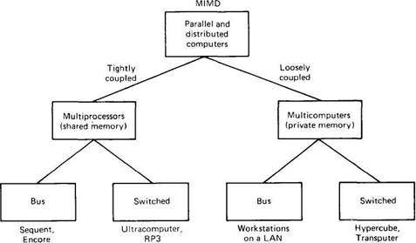 | 5 | 3 | 1 | 1 | 1.6.1*

*Performance Indicators are available separately for Computer Science and Engineering in AICTE examination reforms policy.

Course Outcome (CO) and Bloom’s level (BL) Coverage in Questions

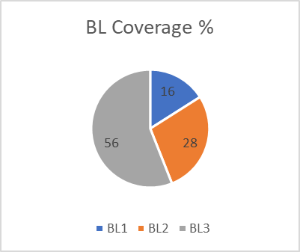

Prepared By Approved by the Audit Professor/Course Coordinator

